[ C PROGRAMMING ASSIGNMENT ]

NAME :- SHUBHAM PRAJAPATI

COURSE :- BTECH ( ELECTRICAL ENGINEERING )

SUBJECT :- PROGRAMMING FUNDAMENTALS FOR ELECTRONICS ENGINEERS

ADMISSION NUMBER :- 25SECE1050013

{C PROGRAMMING ASSIGNMENT}

1.Matrix multiplication

#code

#include<stdio.h>

int main() {
int r1, c1, r2, c2, i, j, k;

printf("Enter rows and cols for matrix A: ");
scanf("%d %d", &r1, &c1);

printf("Enter rows and cols for matrix B: ");
scanf("%d %d", &r2, &c2);

if(c1 != r2) {
printf("Error: Matrix multiplication not possible\n");
return 0;
}

int a[r1][c1], b[r2][c2], result[r1][c2];

printf("Enter elements of matrix A:\n");
for(i = 0; i < r1; i++) {
for(j = 0; j < c1; j++) {
scanf("%d", &a[i][j]);
}
}

printf("Enter elements of matrix B:\n");
for(i = 0; i < r2; i++) {
for(j = 0; j < c2; j++) {
scanf("%d", &b[i][j]);
}
}
for(i = 0; i < r1; i++) {
for(j = 0; j < c2; j++) {
result[i][j] = 0;
}
}
for(i = 0; i < r1; i++) {
for(j = 0; j < c2; j++) {
for(k = 0; k < c1; k++) {
result[i][j] += a[i][k] * b[k][j];
}
}
}

printf("Result matrix:\n");

for(i = 0; i < r1; i++) {
for(j = 0; j < c2; j++) {
printf("%d ", result[i][j]);
}
printf("\n");
}

return 0;
}</stdio.h>

#output

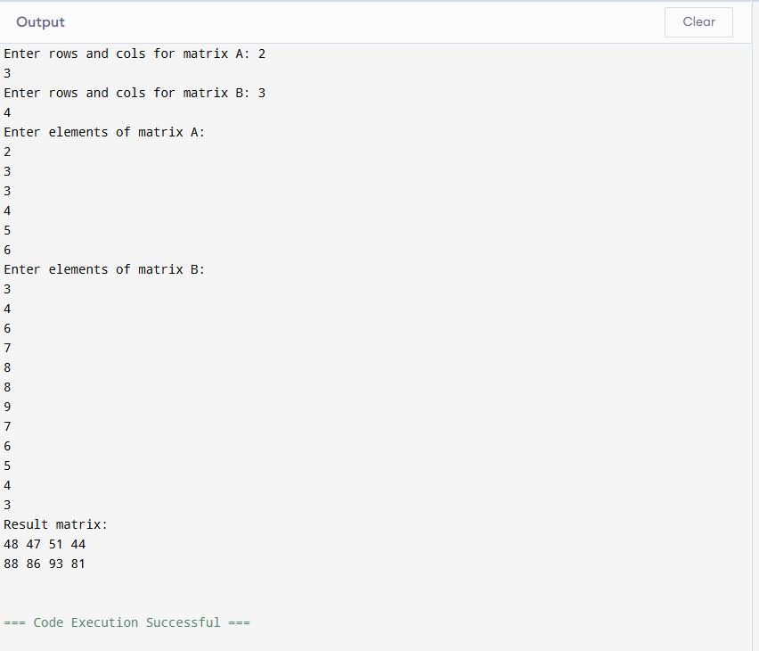

2.string palindrome without library functions

#code

#include <stdio.h>

int main() {
char str[100];
int length = 0, i, isPalindrome = 1;

printf("Enter a string: ");
scanf("%s", str);

while (str[length] != '\0') {
length++;
}

for (i = 0; i < length / 2; i++) {
// Compare character at index i with character at symmetric position from end
if (str[i] != str[length - 1 - i]) {
isPalindrome = 0; // Not a palindrome
break;
}
}

if (isPalindrome) {
printf("%s is a palindrome.\n", str);
} else {
printf("%s is not a palindrome.\n", str);
}

return 0;
}

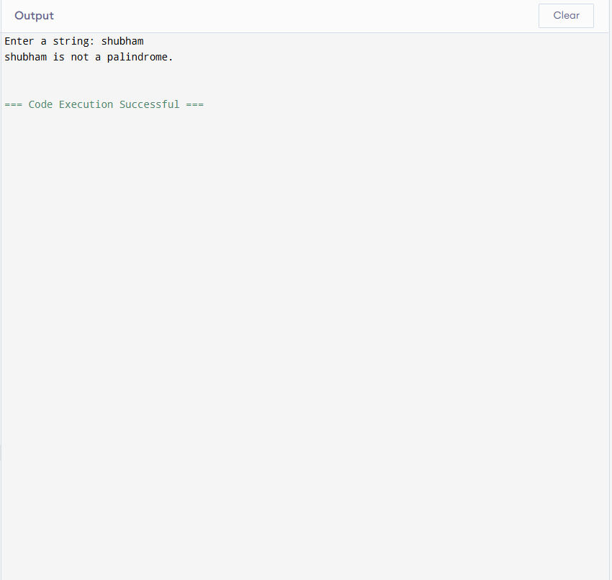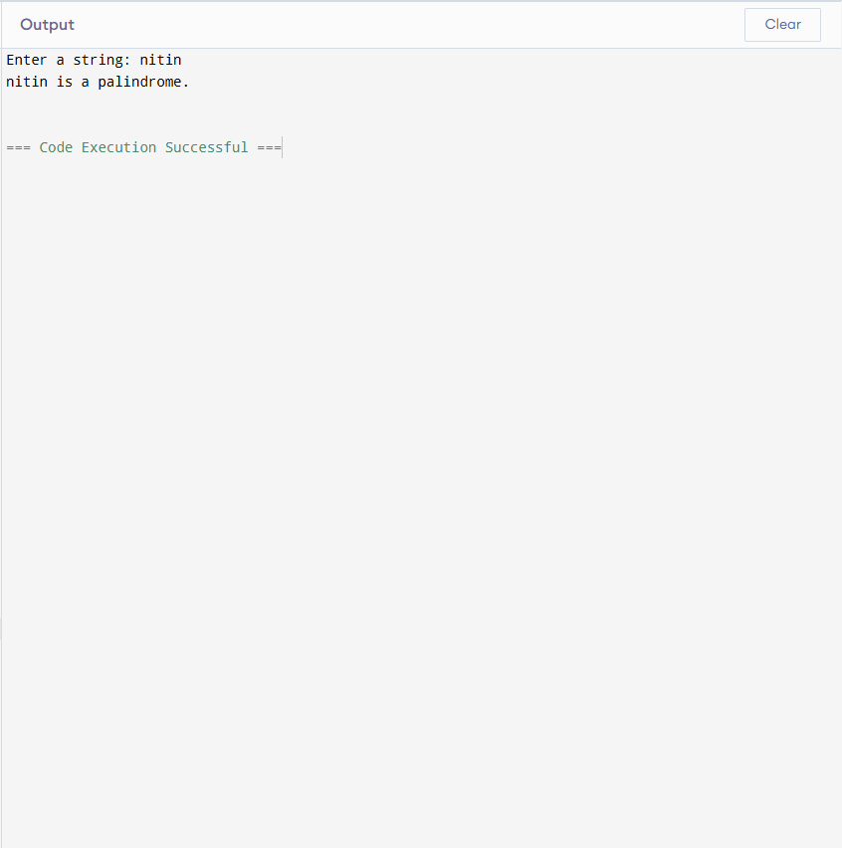
3. File handling - Count words , characters ,lines

#code

#include <stdio.h>
#include <ctype.h>

int main() {
FILE *file;
char filename[100];
int ch;
int characters = 0, words = 0, lines = 0;
int in_word =

printf("Enter the filename: ");
scanf("%s", filename);

file = fopen(filename, "r");

if (file == NULL) {
printf("Could not open file %s\n", filename);
return 1;
}

while ((ch = fgetc(file)) != EOF) {
characters++;

if (ch == '\n') {
lines++;
}

if (isspace(ch)) {
in_word = 0;
} else if (in_word == 0) {
in_word = 1;
words++;
}
}

fclose(file);
printf("\n--- File Statistics ---\n");
printf("Characters: %d\n", characters);
printf("Words: %d\n", words);
printf("Lines: %d\n", lines);

return 0;
}

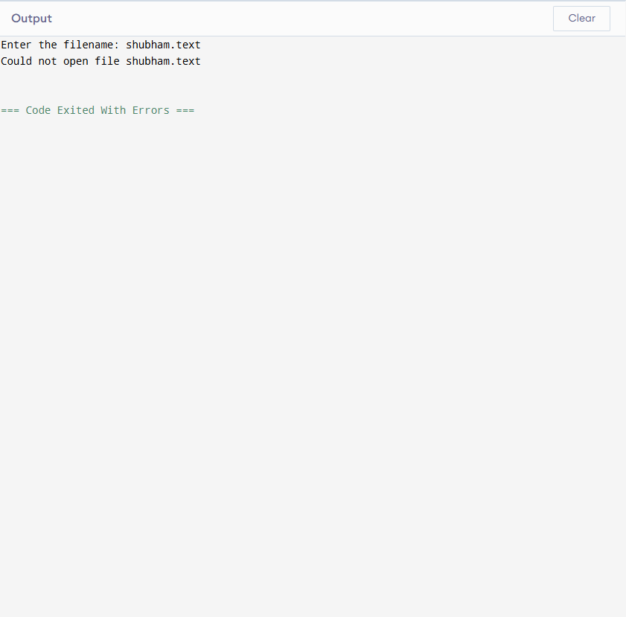

4. structure - student records

#code

#include <stdio.h>

struct Student {
char name[50];
int roll;
float marks;
};

int main() {
int n, i, topperIndex = 0;

printf("Enter number of students: ");
scanf("%d", &n);

struct Student s[n];

for(i = 0; i < n; i++) {
printf("\nEnter details for Student %d:\n", i + 1);
printf("Name: ");
scanf("%s", s[i].name);
printf("Roll Number: ");
scanf("%d", &s[i].roll);
printf("Marks: ");
scanf("%f", &s[i].marks);

if (s[i].marks > s[topperIndex].marks) {
topperIndex = i;
}
}

printf("\n--- All Student Records ---\n");
for(i = 0; i < n; i++) {
printf("Roll: %d | Name: %s | Marks: %.2f\n", s[i].roll, s[i].name, s[i].marks);
}

printf("\n--- TOPPER DETAILS ---\n");
printf("Name: %s\n", s[topperIndex].name);
printf("Roll No: %d\n", s[topperIndex].roll);
printf("Highest Marks: %.2f\n", s[topperIndex].marks);

return 0;
}
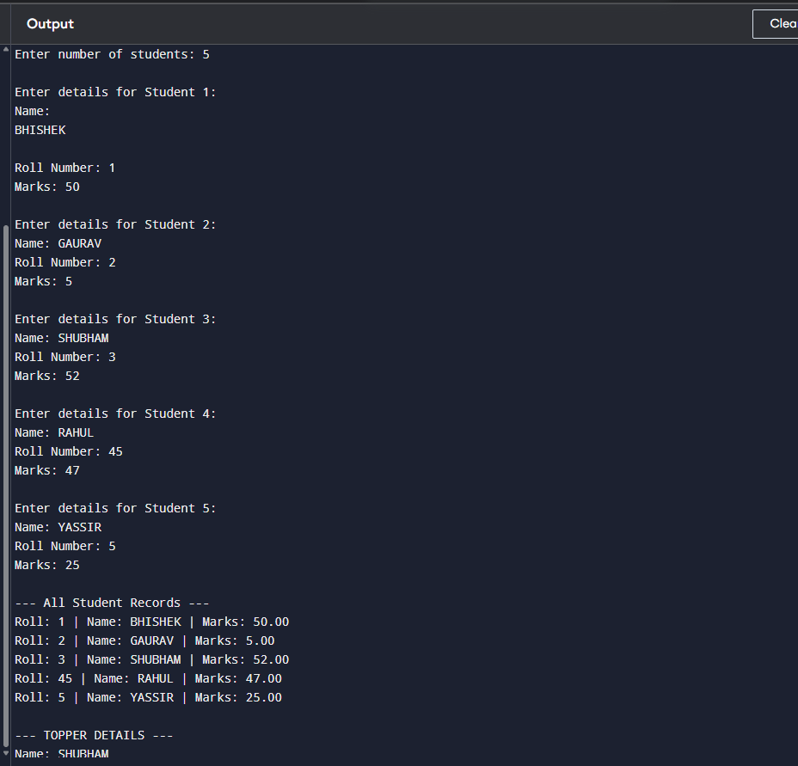
5.pointers - based array sum

#code

#include <stdio.h>
int main() {
int length, sum = 0;
printf("Enter the number of elements: ");
scanf("%d", &length);

int arr[length];
printf("Enter %d elements:\n", length);
for (int i = 0; i < length; i++) {
scanf("%d", &arr[i]);
}
int *ptr = arr;
for (int i = 0; i < length; i++) {
sum += *(ptr + i);
}
printf("The sum of the array elements is: %d\n", sum);

return 0;
}

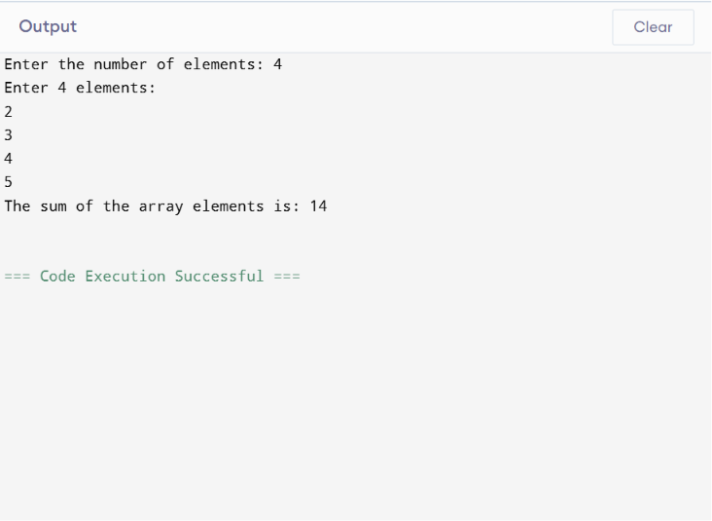
6.Sorting(without Built -in)

#code

#include <stdio.h>
int main() {
int n, i, j, temp;
printf("Enter number of elements: ");
scanf("%d", &n);
int arr[n];
printf("Enter %d elements:\n", n);
for(i = 0; i < n; i++) {
scanf("%d", &arr[i]);
}
for(i = 0; i < n - 1; i++) {
for(j = 0; j < n - i - 1; j++) {
if(arr[j] > arr[j + 1]) {
temp = arr[j];
arr[j] = arr[j + 1];
arr[j + 1] = temp;
}
}
}
printf("Sorted array in ascending order:\n");

for(i = 0; i < n; i++) {
printf("%d ", arr[i]);
}

return 0;
}
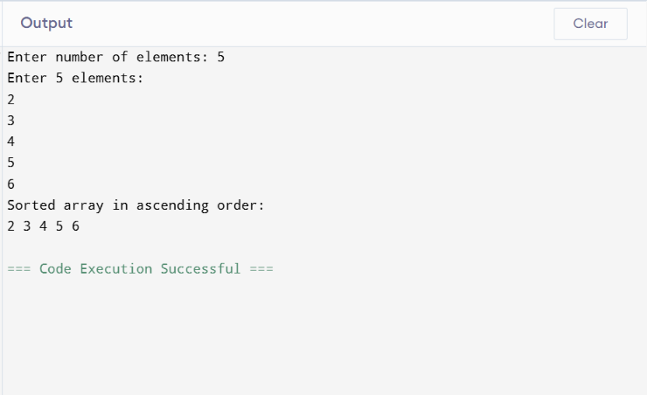

7.Fibonacci using Recursion

#code
#include <stdio.h>
int fibonacci(int n) {
if(n == 0)
return 0;
else if(n == 1)
return 1;
else
return fibonacci(n - 1) + fibonacci(n - 2);
}
int main() {
int n, i;
printf("Enter number of terms: ");
scanf("%d", &n);

printf("Fibonacci Series:\n");
for(i = 0; i < n; i++) {
printf("%d ", fibonacci(i));
}

return 0;
}

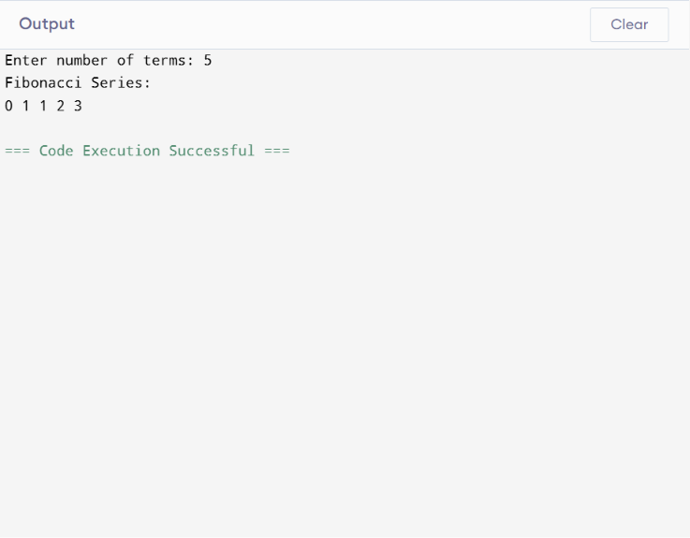
8. Find Second Largest Element

#code

#include <stdio.h>
int main() {
int n, i;
printf("Enter number of elements: ");
scanf("%d", &n);
int arr[n];
printf("Enter array elements:\n");
for(i = 0; i < n; i++) {
scanf("%d", &arr[i]);
}

int largest, secondLargest;
if(arr[0] > arr[1]) {
largest = arr[0];
secondLargest = arr[1];
} else {
largest = arr[1];
secondLargest = arr[0];
}

for(i = 2; i < n; i++) {
if(arr[i] > largest) {
secondLargest = largest;
largest = arr[i];
}
else if(arr[i] > secondLargest && arr[i] != largest) {
secondLargest = arr[i];
}
}

printf("Second largest number = %d\n", secondLargest);

return 0;
}

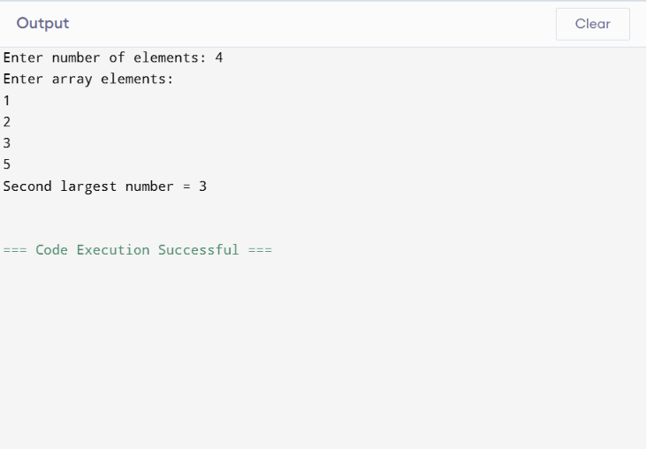

9. Menu-Driven Calculator

#code
#include <stdio.h>
float add(float a, float b);
float subtract(float a, float b);
float multiply(float a, float b);
float divide(float a, float b);
int main() {
int choice;
float num1, num2, result;
while (1) {
printf("\n===== Calculator Menu =====\n");
printf("1. Add\n");
printf("2. Subtract\n");
printf("3. Multiply\n");
printf("4. Divide\n");
printf("5. Exit\n");

printf("Enter your choice: ");
scanf("%d", &choice);
if (choice == 5) {
printf("Exiting program...\n");
break;
}

printf("Enter two numbers: ");
scanf("%f %f", &num1, &num2);

switch (choice) {
case 1:
result = add(num1, num2);
printf("Result = %.2f\n", result);
break;

case 2:
result = subtract(num1, num2);
printf("Result = %.2f\n", result);
break;

case 3:
result = multiply(num1, num2);
printf("Result = %.2f\n", result);
break;

case 4:
result = divide(num1, num2);
if (num2 != 0)
printf("Result = %.2f\n", result);
break;

default:
printf("Invalid choice!\n");
}
}

return 0;
}

float add(float a, float b) {
return a + b;
}

float subtract(float a, float b) {
return a - b;
}

float multiply(float a, float b) {
return a * b;
}

float divide(float a, float b) {
if (b == 0) {
printf("Division by zero is not allowed!\n");
return 0;
}
return a / b;
}

